Day 11
Task 1:
In Spring Boot, Actuator is a production-ready feature that helps you monitor, manage, and inspect your application while it is running.
Task 2:
- Health Monitoring – Checks whether the application and its dependencies are running properly.
- Performance Metrics – Provides insights into CPU, memory, requests, and JVM performance.
- Production Monitoring – Enables real-time monitoring of applications in production environments.
- Easy Troubleshooting – Helps diagnose issues using logs, thread dumps, and heap dumps.
- Runtime Insights – Exposes application configuration, beans, and environment details.
Task 3:
- /actuator/health – Shows the health status of the application.
- /actuator/info – Displays custom application information.
- /actuator/metrics – Provides application and JVM performance metrics.
- /actuator/env – Shows environment properties and configuration values.
- /actuator/beans – Lists all Spring-managed beans in the application.
Task 4:
(GitHub)
Task 5:
Spring Security Architecture is the framework structure that handles authentication (who you are) and authorization (what you can access) by intercepting incoming requests through a chain of security filters before they reach the application.
Task 6:
- SecurityFilterChain
- Authentication
- AuthenticationManager
- AuthenticationProvider
- UserDetailsService
- UserDetails
- SecurityContext
- SecurityContextHolder
- Authorization
Task 7:
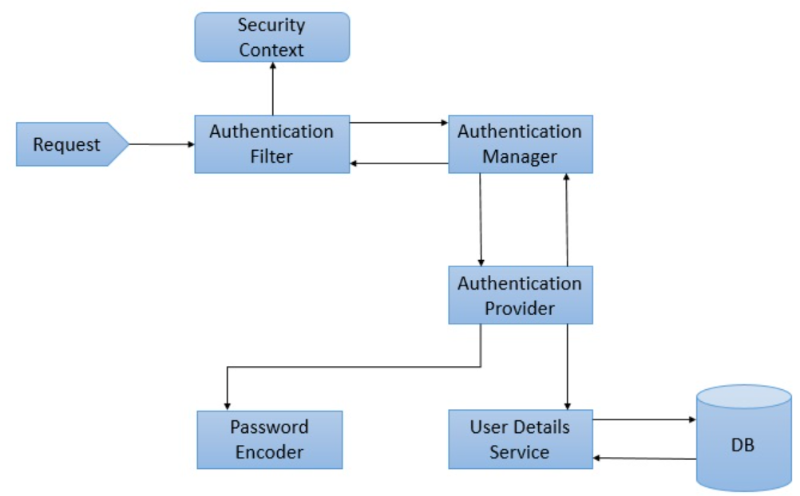
Task 8:
A SecurityFilterChain is a collection of security filters that intercept every incoming HTTP request and apply security rules such as authentication, authorization, CSRF protection, session management, etc., before the request reaches the controller.
Task 9:
AuthenticationManager is the core Spring Security component responsible for authenticating a user's credentials (username/password, JWT, etc.).
It receives an authentication request, delegates it to an AuthenticationProvider, and returns an authenticated object if the credentials are valid.
Task 10:
An AuthenticationProvider is a Spring Security component that verifies a user's credentials and determines whether authentication is successful.
It receives the authentication request from the AuthenticationManager, validates the credentials, and returns an authenticated user if the credentials are correct.

Task 11:
UserDetailsService is a core Spring Security interface used to load user details from a database, LDAP, or any other source during authentication.
Task 12:
PasswordEncoder is a Spring Security interface used to encrypt (hash) passwords before storing them and verify passwords during login.
- Protects passwords from being stored in plain text.
- Commonly uses algorithms like BCrypt, SCrypt, and PBKDF2.
Task 13:
SecurityContextHolder is a Spring Security class that stores and provides access to the currently authenticated user's details throughout the application.
After a user successfully logs in, Spring Security stores the user's authentication information in the SecurityContext, which can be accessed via SecurityContextHolder.
Task 14:
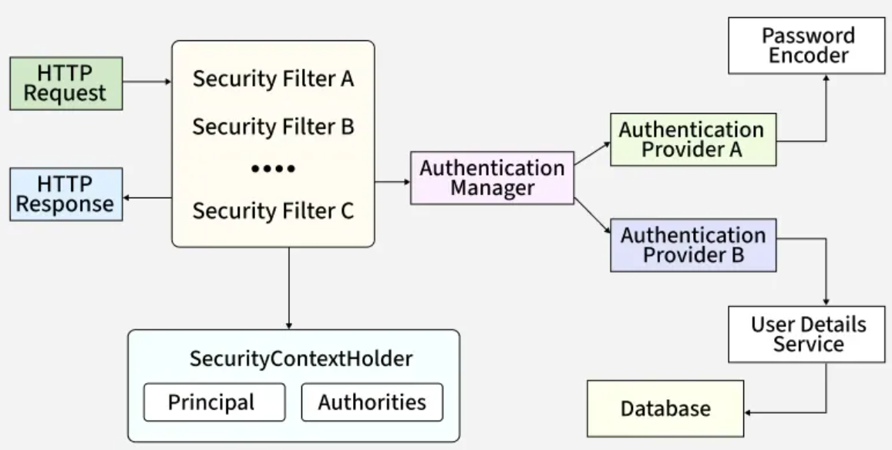
Task 15:
Thymeleaf is a Java-based server-side template engine used to create dynamic web pages in Spring and Spring Boot applications.
It allows you to combine HTML + Java data to generate dynamic content that is sent to the browser.
Thymeleaf is used to:
- Create dynamic web pages
- Display data from the backend on HTML pages
- Handle forms and user input
- Integrate seamlessly with Spring Boot
Task 16:
(GitHub)
Task 17:
- Easy to learn and use with standard HTML syntax
- Seamlessly integrates with Spring Boot and Spring MVC
- Supports dynamic content rendering
- Simplifies form handling and data binding
- Supports reusable templates (fragments, headers, footers)
- Generates clean and SEO-friendly HTML
- Natural templates can be viewed directly in a browser
- Automatically escapes HTML to help prevent XSS attacks
- Reduces JavaScript dependency for server-side rendered applications
- Improves code maintainability by separating UI and business logic
Task 18:
Caching is a technique used to store frequently accessed data in memory so that future requests can be served faster without repeatedly fetching data from the database or executing expensive operations.
Why Caching?
- Improves application performance
- Reduces database load
- Decreases response time
- Improves scalability
- Reduces network calls to external services
Task 19:
- Auto Configuration – Automatically configures Spring application components based on dependencies.
- Embedded Servers – Supports Tomcat, Jetty, and Undertow out of the box.
- Starter Dependencies – Simplifies dependency management using starters like spring-boot-starter-web.
- Production-Ready Features – Includes Actuator for health checks, metrics, and monitoring.
- Spring Initializer Support – Quickly generates project structure and dependencies.
- Caching Support – Supports caching using annotations and various cache providers.
- Testing Support – Simplifies unit and integration testing with Spring Test and JUnit.
Task 20:
- In-Memory Cache – Stores data in the application's memory for faster access.
- Distributed Cache – Stores data in a shared cache accessible by multiple application instances.
- Cache-Aside (Lazy Loading) – Loads data into the cache only when it is requested.
- Refresh-Ahead Cache – Refreshes frequently accessed cache entries before they expire.
Task 21:
- @EnableCaching – Enables caching functionality in a Spring Boot application.
- @Cacheable – Stores a method's result in the cache and returns cached data on subsequent calls.
- @CachePut – Updates the cache with the latest method result every time the method executes.
- @Caching – Combines multiple cache operations in a single annotation.
- @CacheConfig – Defines common cache settings at the class level to avoid repetition.
Task 22:
@InjectMocks is a Mockito annotation that creates an instance of the class you want to test and automatically injects the mock dependencies into it.

Task 23:
@Spy annotation is used to create a partial mock of a real object.
Unlike @Mock, which creates a completely fake object, @Spy creates a real object and allows you to:
- Use the actual implementation of methods.
- Override (stub) specific methods when needed.
- Verify method interactions.
Task 24:
The @Mock annotation in Mockito is used to create a mock (fake) object of a class or interface for testing purposes.
Task 25:
Partial mocking means creating a mock object where some methods use the real implementation and some methods are mocked.
This is useful when you want to test the actual behaviour of a class while overriding specific methods.
Mockito uses the @Spy annotation for partial mocking.
- @Mock - Creates a completely fake object.
- @Spy - Creates a real object and allows selected methods to be mocked.
Task 26:
verify () is used to check whether a method on a mock object was called during test execution.
Task 27:
- @Mock – Creates a mock (fake) object for testing.
- @InjectMocks – Creates the class under test and injects the mock dependencies into it.
- @Spy – Creates a partial mock that uses real methods unless stubbed.
- @Captor – Captures method arguments passed to a mock for verification.
- @MockBean – Creates a mock bean and adds it to the Spring Application Context.
- @MockitoSettings – Configures Mockito behaviour such as strictness settings.
- @DoNotMock – Indicates that a class should not be mocked and suggests using a real instance instead.

